**Step 1: Download ‘AutoItX4Java.jar’ from Below link:**

<https://storage.googleapis.com/google-code-archive-downloads/v2/code.google.com/autoitx4java/AutoItX4Java.jar>

**Step 2: Create a Project in eclipse and create a folder name as “lib” inside Project**

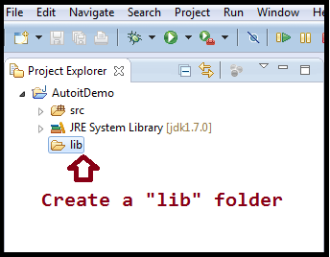

**Step 3: Download  JACOB**

<https://sourceforge.net/projects/jacob-project/files/?source=navbar>

**Step 4: After download extract  the zip file then copy the only marked file**

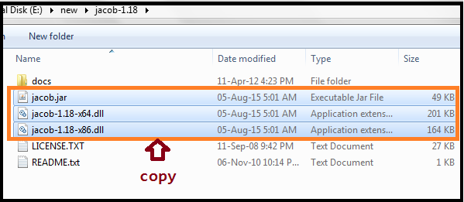

**Step 5: Paste the copied file inside lib folder**

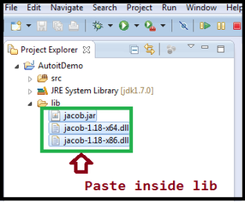

**Step 6: Paste AutoItX4java.jar file inside lib folder**

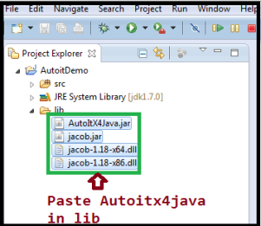

**Step 7: Create tools folder Inside your project**

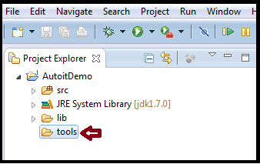

**Step 8:Create autoIt folder inside tools folder**

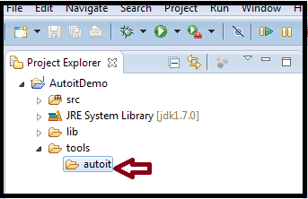

**Step 9:In your system where autoit is installed Go there – 32 bit system copy-AutoItX3.dll- for 64 bit system  copy -AutoItX3_x64.dll (I gave that My system 32 bit example)**

**My system autoit Path :C:\Program Files (x86)\AutoIt3\AutoItX**

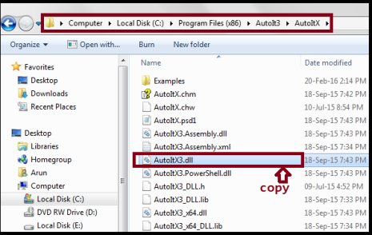

**Step 10: Copied file paste inside tools/autoit folder**

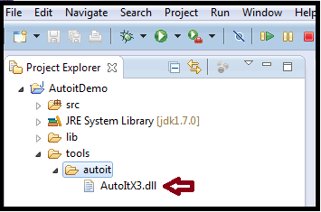

**Step 11:Add below  jars into your project**

**1.AutoItX4Java.jar  
2.Jacob.jar**

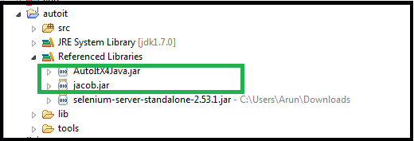

**Step 12: Right click on tools/autoit /AutoItX3.dll   – get the path of the file**

E:\new\workspace\AutoitDemo\tools\autoit\AutoItX3.dll

**Step 13: Go  system Start Menu type in search** (**remeber yor  project inside tools\autoit that path have tomention**)

“regsvr32 E:\new\workspace\AutoitDemo\tools\autoit\AutoItX3.dll”

Press enter you will  success registration  conformation popup

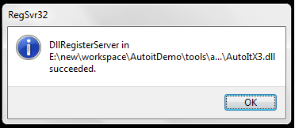

**Try the below code:**

import java.io.File;

import java.util.concurrent.TimeUnit;

import org.openqa.selenium.By;

import org.openqa.selenium.WebDriver;

import org.openqa.selenium.firefox.FirefoxDriver;

import autoitx4java.AutoItX;

import com.jacob.com.LibraryLoader;

public class sam

{

public static void main(String[] args) throws InterruptedException

{

String jacobDllVersionToUse;

if(System.getProperty("sun.arch.data.model").contains("32"))

{

jacobDllVersionToUse = "jacob-1.18-x86.dll";

}

else {

jacobDllVersionToUse = "jacob-1.18-x64.dll";

}

File file = new File("lib", jacobDllVersionToUse);

System.setProperty(LibraryLoader.JACOB_DLL_PATH, file.getAbsolutePath());

WebDriver driver =new FirefoxDriver();

driver.manage().timeouts().implicitlyWait(10, TimeUnit.SECONDS);

driver.get("https://response.naukri.com/responsemanager/upload/resume?vjobid=S502103373ae0f&vsource=Branch");

driver.findElement(By.id("textCV")).click();

Thread.sleep(2000);

AutoItX x = new AutoItX();

x.winWaitActive("File Upload");

x.sleep(1000);

x.send("C:\\Users\\Arun\\Downloads\\1954458_133791_7577250987.pdf");

x.sleep(1000);

x.controlClick("File Upload", "", "1") ;

}

}

Advertisements

Report this ad

Report this ad

**Share this:**

* [Twitter](https://arunseleniumhelp.wordpress.com/2016/08/02/using-autoit-jar-in-eclipse/?share=twitter&nb=1)
* [Facebook](https://arunseleniumhelp.wordpress.com/2016/08/02/using-autoit-jar-in-eclipse/?share=facebook&nb=1)
* [Google](https://arunseleniumhelp.wordpress.com/2016/08/02/using-autoit-jar-in-eclipse/?share=google-plus-1&nb=1)

Leave a Reply

Top of Form



Bottom of Form

POST NAVIGATION

[← PREVIOUS POST](https://arunseleniumhelp.wordpress.com/2016/08/01/using-autoit-tool/)

[NEXT POST →](https://arunseleniumhelp.wordpress.com/2016/08/05/java-robot-class/)

[BLOG AT WORDPRESS.C](https://wordpress.com/?ref=footer_blog)